LIFE SAVER

The main aim of the project entitled “LIFE SAVER” is to provide an application for the Blood Banks. The ‘Life Saver’ wants to provide the Information regarding hospitals, blood banks, customers and donors.

This project is developed with 4 layers, which are:

1) Aboutus
2) Blood Banks
3) Customer
4) Donor

- Aboutus
Gives the details about the hospitals, blood banks and donors in a particular place (like state, city, location).
- Blood Bank
The blood bank provides the details about the types of bloods available in that blood bank.
- Donor
The donor is a person who gives blood to different blood banks depending upon their blood groups.
- Customer
The customers can view details of the blood banks and their addresses.

2. SYSTEM REQUIRE MENTS AND ANALYSIS

2.1 SYSTEM ENVIRONMENT

This gives details relating to the environment in which the software is developed. Given below are the hardware and the software that are used while developing this software.

The software developed should be compatible to Windows NT/2000. It should be developed to use its business logic components to facilitate client/server architecture to enabled update version to be developed.

2.1.1 HARDWARE REQUIREMENTS

The system should have the following minimum configuration

166 MHz Processor
16 MB RAM
300 GB Hard Disk Drive

512 KB Cache
1.44” Floppy Disk Drive
Mouse Standard Mouse
Keyboard 109 keys Keyboard
14" Color Monitor (color)

2.1.2 SOFTWARE REQUIREMENTS

Front End :Java(jsp’s, Servlets), HTML, Xml.
Back End :Oracle.
Server :Tomcat5.5

INTRODUCTION TO WINDOWS

MicroSoft Corporation windows in Nov 1983 and was released 2 years later in Nov 1985 its introduction. MS-windows has emerged as the most popular GUI environment for MS-DOS. For the user, Windows provide a multitasking, graphical based windowing environment that runs especially designed for windows.

Windows have a consistent appearance, command structure, and are thus often easier to lean use than conventional MS-DOS program. Users can easily switch among different windows programs and exchange data between them. Windows also provide and exchange to use icon based program manager for running programs. Although windows exist primarily to run applications especially written for the environment, windows also can run many programs written for MS-DOS. For the program developer, Windows provide a wealth of insult routines that allow the use of menus, dialog boxes, scroll bars and other components of friendly user interface. Windows also contains an extension graphics programming languages that includes the use of formatted text in a variety of fonts.

FEATURES:

The Graphic User Interface (GUI):

Windows is Graphical User Interface, sometimes also called as “Visual Interface” or “ Graphical Windowing Environment”. All Graphical User Interface make use of graphics on a bitmapped video display. Graphical provides better utilization of screen real estate a visually rich environment for conveying information, and the possibility of WYSIWG video display of graphics and formatted text prepared for a printed document.

The Consistent User Interface:

User no longer expects to spend long periods learning how to use the computer or mastering a new program. Windows helps because all windows programs have the same fundamental look and feel. The program occupies a window, a rectangle area on the screen. A captain bar identifies it. Most program functions are indicated through the program menu.

The Multitasking Advantage:

Under windows, every program in effect becomes RAM resident pop-up. Several windows program can be displayed running at the same time. The user can move the windows around in the screen, change their size, and switch between different programs, and transfer data from one program to another.

Memory Management:

An Operating System cannot implement multitasking without doing something about memory management. As new programs are started up and old ones terminate, memory can be fragmented. The system must be able to move the blocks of code and data in memory space. Windows can overcoat memory; a program can contain mode code than can fit into memory at any one time. A user can run several copies of program; all these instances share the same code in the memory. Programs running in windows can share routines located in other.

Dynamic Linking:

A windows program interfaces to windows through a process called “Dynamic Linking”. Like MS-DOS programs, windows executable filename extension .EXE format called the new executable file format. Whenever a windows program calls a windows function, the “C” compiler generates assembly language code for a far call. A table in the .EXE file identifies the function being called using a dynamic link library name and either a name or a number of the function.

FRONT END TOOL

Features of The Language Used
In my project, I have chosen Java language for developing the code.

About Java
Initially the language was called as “oak” but it was renamed as “Java” in 1995. The primary motivation of this language was the need for a platform-independent (i.e., architecture neutral) language that could be used to create software to be embedded in various consumer electronic devices.
- Java is a programmer’s language.
- Java is cohesive and consistent.
- Except for those constraints imposed by the Internet environment, Java gives the programmer, full control.
- Finally, Java is to Internet programming where C was to system programming.

Importance of Java to the Internet
Java has had a profound effect on the Internet. This is because; Java expands the Universe of objects that can move about freely in Cyberspace. In a network, two categories of objects are transmitted between the Server and the Personal computer. They are: Passive information and Dynamic active programs. The Dynamic, Self-executing programs cause serious problems in the areas of Security and probability. But, Java addresses those concerns and by doing so, has opened the door to an exciting new form of program called the Applet.

Java can be used to create two types of programs
Applications and Applets: An application is a program that runs on our Computer under the operating system of that computer. It is more or less like one creating using C or C++. Java’s ability to create Applets makes it important. An Applet is an application designed to be transmitted over the Internet and executed by a Java –compatible web browser. An applet is actually a tiny Java program, dynamically downloaded across the network, just like an image. But the difference is, it is an intelligent program, not just a media file. It can react to the user input and dynamically change.

Features Of Java Security
Every time you that you download a “normal” program, you are risking a viral infection. Prior to Java, most users did not download executable programs frequently, and those who did scanned them for viruses prior to execution. Most users still worried about the possibility of infecting their systems with a virus. In addition, another type of malicious program exists that must be guarded against. This type of program can gather private information, such as credit card numbers, bank account balances, and passwords. Java answers both these concerns by providing a “firewall” between a network application and your computer.
When you use a Java-compatible Web browser, you can safely download Java applets without fear of virus infection or malicious intent.

Portability
For programs to be dynamically downloaded to all the various types of platforms connected to the Internet, some means of generating portable executable code is needed .As you will see, the same mechanism that helps ensure security also helps create portability. Indeed, Java’s solution to these two problems is both elegant and efficient.

The Byte code
The key that allows the Java to solve the security and portability problems is that the output of Java compiler is Byte code. Byte code is a highly optimized set of instructions designed to be executed by the Java run-time system, which is called the Java Virtual Machine (JVM). That is, in its standard form, the JVM is an interpreter for byte code.
Translating a Java program into byte code helps makes it much easier to run a program in a wide variety of environments. The reason is, once the run-time package exists for a given system, any Java program can run on it.
Although Java was designed for interpretation, there is technically nothing about Java that prevents on-the-fly compilation of byte code into native code. Sun has just completed its Just In Time (JIT) compiler for byte code. When the JIT compiler is a part of JVM, it compiles byte code into executable code in real time, on a piece-by-piece, demand basis. It is not possible to compile an entire Java program into executable code all at once, because Java performs various run-time checks that can be done only at run time. The JIT compiles code, as it is needed, during execution.

Java Virtual Machine (JVM)
Beyond the language, there is the Java virtual machine. The Java virtual machine is an important element of the Java technology. The virtual machine can be embedded within a web browser or an operating system. Once a piece of Java code is loaded onto a machine, it is verified. As part of the loading process, a class loader is invoked and does byte code verification makes sure that the code that’s has been generated by the compiler will not corrupt the machine that it’s loaded on. Byte code verification takes place at the end of the compilation process to make sure that is all accurate and correct. So byte code verification is integral to the compiling and executing of Java code.

Overall Description
Java Source
Java byte code
JavaVM
Java
.Class

Picture showing the development process of JAVA Program
Java programming uses to produce byte codes and executes them. The first box indicates that the Java source code is located in a. Java file that is processed with a Java compiler called javac. The Java compiler produces a file called a. class file, which contains the byte code. The. Class file is then loaded across the network or loaded locally on your machine into the execution environment is the Java virtual machine, which interprets and executes the byte code.

Java Architecture
Java architecture provides a portable, robust, high performing environment for development. Java provides portability by compiling the byte codes for the Java Virtual Machine, which is then interpreted on each platform by the run-time environment. Java is a dynamic system, able to load code when needed from a machine in the same room or across the planet.

Compilation of code
When you compile the code, the Java compiler creates machine code (called byte code) for a hypothetical machine called Java Virtual Machine (JVM). The JVM is supposed to execute the byte code. The JVM is created for overcoming the issue of portability. The code is written and compiled for one machine and interpreted on all machines. This machine is called Java Virtual Machine.

Compiling and interpreting Java Source Code

During run-time the Java interpreter tricks the byte code file into thinking that it is running on a Java Virtual Machine. In reality this could be a Intel Pentium Windows 95 or SunSARC station running Solaris or Apple Macintosh running system and all could receive code from any computer through Internet and run the Applets.
Source
Code
………..
………..

………..

…………

PC Compiler
Macintosh
Compiler
SPARC
Compiler
Java

Byte code

(Platform
Indepen
dent)
Java
Interpreter
(PC)
Java
Interpreter
(Macintosh)
Java
Interpreter
(Spare)

Simple
Java was designed to be easy for the Professional programmer to learn and to use effectively. If you are an experienced C++ programmer, learning Java will be even easier. Because Java inherits the C/C++ syntax and many of the object oriented features of C++. Most of the confusing concepts from C++ are either left out of Java or implemented in a cleaner, more approachable manner. In Java there are a small number of clearly defined ways to accomplish a given task.

Object-Oriented
Java was not designed to be source-code compatible with any other language. This allowed the Java team the freedom to design with a blank slate. One outcome of this was a clean usable, pragmatic approach to objects. The object model in Java is simple and easy to extend, while simple types, such as integers, are kept as high-performance non-objects.

Robust
The multi-platform environment of the Web places extraordinary demands on a program, because the program must execute reliably in a variety of systems. The ability to create robust programs was given a high priority in the design of Java. Java is strictly typed language; it checks your code at compile time and run time.
Java virtually eliminates the problems of memory management and deallocation, which is completely automatic. In a well-written Java program, all run time errors can –and should –be managed by your program.

Servlets, JSP, JDBC & HTML Technologies

SERVLETS

Introduction
The Java web server is JavaSoft's own web Server. The Java web server is just a part of a larger framework, intended to provide you not just with a web server, but also with tools. To build customized network servers for any Internet or Intranet client/server system. Servlets are to a web server, how applets are to the browser.

About Servlets
Servlets provide a Java-based solution used to address the problems currently associated with doing server-side programming, including inextensible scripting solutions, platform-specific APIs, and incomplete interfaces.
Servlets are objects that conform to a specific interface that can be plugged into a Java-based server. Servlets are to the server-side what applets are to the client-side - object byte codes that can be dynamically loaded off the net. They differ from applets in that they are faceless objects (without graphics or a GUI component). They serve as platform independent, dynamically loadable, plugable helper byte code objects on the server side that can be used to dynamically extend server-side functionality.
For example, an HTTP Servlets can be used to generate dynamic HTML content. When you use Servlets to do dynamic content you get the following advantages:
- They’re faster and cleaner than CGI scripts
- They use a standard API (the Servlets API)
- They provide all the advantages of Java (run on a variety of servers without needing to be rewritten).

Attractiveness of Servlets
There are many features of Servlets that make them easy and attractive to use. These include:
- Easily configured using the GUI-based Admin tool
- Can be loaded and invoked from a local disk or remotely across the network.
- Can be linked together, or chained, so that one Servlets can call another Servlets, or several Servlets in sequence.
- Can be called dynamically from within HTML pages, using server-side include tags.
- Are secure - even when downloading across the network, the Servlets security model and Servlets sandbox protect your system from unfriendly behavior.

Advantages of the Servlet API
One of the great advantages of the Servlet API is protocol independence. It assumes nothing about:
- The protocol being used to transmit on the net
- How it is loaded
- The server environment it will be running in

These qualities are important, because it allows the Servlet API to be embedded in many different kinds of servers. There are other advantages to the Servlet API as well. These include:
- It’s extensible - you can inherit all your functionality from the base classes made available to you.
- It’s simple, small, and easy to use.

Features of Servlets
- Servlets are persistent. Servlet are loaded only by the web server and can maintain services between requests.
- Servlets are fast. Since Servlets only need to be loaded once, they offer much better performance over their CGI counterparts.
- Servlets are platform independent.
- Servlets are extensible. Java is a robust, object-oriented programming language, which easily can be extended to suit your needs
- Servlets are secure.
- Servlets can be used with a variety of clients.

Loading Servlets

Servlets can be loaded from three places
From a directory that is on the CLASSPATH. The CLASSPATH of the JavaWebServer includes service root/classes/ which is where the system classes reside.
From the <SERVICE_ROOT /Servlets/ directory. This is *not* in the server’s class path. A class loader is used to create Servlets from this directory. New Servlets can be added - existing Servlets can be recompiled and the server will notice these changes.
From a remote location. For this a code base like http: // nine.eng / classes / foo / is required in addition to the Servlets class name. Refer to the admin GUI docs on Servlet section to see how to set this up.

Loading Remote Servlets
Remote Servlets can be loaded by:
- Configuring the Admin Tool to setup automatic loading of remote Servlets
- Setting up server side include tags in. shtml files
- Defining a filter chain configuration

Invoking Servlets
A Servlet invoker is a Servlet that invokes the "service" method on a named Servlet. If the Servlet is not loaded in the server, then the invoker first loads the Servlet (either from local disk or from the network) and the then invokes the "service" method. Also like applets, local Servlets in the server can be identified by just the class name. In other words, if a Servlet name is not absolute, it is treated as local.
A client can invoke Servlets in the following ways:
- The client can ask for a document that is served by the Servlet.
- The client (browser) can invoke the Servlet directly using a URL, once it has been mapped using the Servlet Aliases section of the admin GUI.
- The Servlet can be invoked through server side include tags.
- The Servlet can be invoked by placing it in the Servlets/ directory.
- The Servlet can be invoked by using it in a filter chain.
JavaScript
JavaScript is a script-based programming language that was developed by Netscape Communication Corporation. JavaScript was originally called Live Script and renamed as JavaScript to indicate its relationship with Java. JavaScript supports the development of both client and server components of Web-based applications. On the client side, it can be used to write programs that are executed by a Web browser within the context of a Web page. On the server side, it can be used to write Web server programs that can process information submitted by a Web browser and then updates the browser’s display accordingly
Even though JavaScript supports both client and server Web programming, we prefer JavaScript at Client side programming since most of the browsers supports it. JavaScript is almost as easy to learn as HTML, and JavaScript statements can be included in HTML documents by enclosing the statements between a pair of scripting tags
<SCRIPTS>.. </SCRIPT>.
<SCRIPT LANGUAGE = “JavaScript”>
JavaScript statements
</SCRIPT>
Here are a few things we can do with JavaScript:
- Validate the contents of a form and make calculations.
- Add scrolling or changing messages to the Browser’s status line.
- Animate images or rotate images that change when we move the mouse over them.
- Detect the browser in use and display different content for different browsers.
- Detect installed plug-ins and notify the user if a plug-in is required.
We can do much more with JavaScript, including creating entire application.

JavaScript Vs Java
JavaScript and Java are entirely different languages. A few of the most glaring differences are:

- Java applets are generally displayed in a box within the web document; JavaScript can affect any part of the Web document itself.
- While JavaScript is best suited to simple applications and adding interactive features to Web pages; Java can be used for incredibly complex applications.

There are many other differences but the important thing to remember is that JavaScript and Java are separate languages. They are both useful for different things; in fact they can be used together to combine their advantages.

Advantages
- JavaScript can be used for Sever-side and Client-side scripting.
- It is more flexible than VBScript.
- JavaScript is the default scripting languages at Client-side since all the browsers supports it.

Hyper Text Markup Language
Hypertext Markup Language (HTML), the languages of the World Wide Web (WWW), allows users to produces Web pages that include text, graphics and pointer to other Web pages (Hyperlinks).
HTML is not a programming language but it is an application of ISO Standard 8879, SGML (Standard Generalized Markup Language), but specialized to hypertext and adapted to the Web. The idea behind Hypertext is that instead of reading text in rigid linear structure, we can easily jump from one point to another point. We can navigate through the information based on our interest and preference. A markup language is simply a series of elements, each delimited with special characters that define how text or other items enclosed within the elements should be displayed. Hyperlinks are underlined or emphasized works that load to other documents or some portions of the same document.
HTML can be used to display any type of document on the host computer, which can be geographically at a different location. It is a versatile language and can be used on any platform or desktop.
HTML provides tags (special codes) to make the document look attractive. HTML tags are not case-sensitive. Using graphics, fonts, different sizes, color, etc., can enhance the presentation of the document. Anything that is not a tag is part of the document itself.

Basic HTML Tags :
<! -- --> Specifies comments
<A>……….</A> Creates hypertext links
<B>……….</B> Formats text as bold
<BIG>……….</BIG> Formats text in large font.
<BODY>…</BODY> Contains all tags and text in the HTML document
<CENTER>...</CENTER> Creates text
<DD>…</DD> Definition of a term
<DL>...</DL> Creates definition list
<FONT>…</FONT> Formats text with a particular font
<FORM>...</FORM> Encloses a fill-out form
<FRAME>...</FRAME> Defines a particular frame in a set of frames
<H#>…</H#> Creates headings of different levels
<HEAD>...</HEAD> Contains tags that specify information about a document
<HR>...</HR> Creates a horizontal rule
<HTML>…</HTML> Contains all other HTML tags
<META>...</META> Provides meta-information about a document
<SCRIPT>…</SCRIPT> Contains client-side or server-side script
<TABLE>…</TABLE> Creates a table
<TD>…</TD> Indicates table data in a table
<TR>…</TR> Designates a table row
<TH>…</TH> Creates a heading in a table
Advantages
- A HTML document is small and hence easy to send over the net. It is small because it does not include formatted information.
- HTML is platform independent.
- HTML tags are not case-sensitive.
Java Database Connectivity
What Is JDBC?
JDBC is a Java API for executing SQL statements. (As a point of interest, JDBC is a trademarked name and is not an acronym; nevertheless, JDBC is often thought of as standing for Java Database Connectivity. It consists of a set of classes and interfaces written in the Java programming language. JDBC provides a standard API for tool/database developers and makes it possible to write database applications using a pure Java API.
Using JDBC, it is easy to send SQL statements to virtually any relational database. One can write a single program using the JDBC API, and the program will be able to send SQL statements to the appropriate database. The combinations of Java and JDBC lets a programmer write it once and run it anywhere.
What Does JDBC Do?

Simply put, JDBC makes it possible to do three things:
- Establish a connection with a database
- Send SQL statements
- Process the results.
JDBC versus ODBC and other APIs
At this point, Microsoft's ODBC (Open Database Connectivity) API is that probably the most widely used programming interface for accessing relational databases. It offers the ability to connect to almost all databases on almost all platforms.
So why not just use ODBC from Java? The answer is that you can use ODBC from Java, but this is best done with the help of JDBC in the form of the JDBC-ODBC Bridge, which we will cover shortly. The question now becomes "Why do you need JDBC?" There are several answers to this question:
- ODBC is not appropriate for direct use from Java because it uses a C interface. Calls from Java to native C code have a number of drawbacks in the security, implementation, robustness, and automatic portability of applications.
- A literal translation of the ODBC C API into a Java API would not be desirable. For example, Java has no pointers, and ODBC makes copious use of them, including the notoriously error-prone generic pointer "void *". You can think of JDBC as ODBC translated into an object-oriented interface that is natural for Java programmers.
- ODBC is hard to learn. It mixes simple and advanced features together, and it has complex options even for simple queries. JDBC, on the other hand, was designed to keep simple things simple while allowing more advanced capabilities where required.
- A Java API like JDBC is needed in order to enable a "pure Java" solution. When ODBC is used, the ODBC driver manager and drivers must be manually installed on every client machine. When the JDBC driver is written completely in Java, however, JDBC code is automatically installable, portable, and secure on all Java platforms from network computers to mainframes.
Two-tier and Three-tier Models
The JDBC API supports both two-tier and three-tier models for database access.

In the two-tier model, a Java applet or application talks directly to the database. This requires a JDBC driver that can communicate with the particular database management system being accessed. A user's SQL statements are delivered to the database, and the results of those statements are sent back to the user. The database may be located on another machine to which the user is connected via a network. This is referred to as a client/server configuration, with the user's machine as the client, and the machine housing the database as the server. The network can be an Intranet, which, for example, connects employees within a corporation, or it can be the Internet.
JAVA
Application
JDBC
DBMS
Client machine
DBMS-proprietary protocol
Database server

Java applet or
Html browser
Application
Server (Java)
JDBC
DBMS
Client machine (GUI)
HTTP, RMI, or CORBA calls
Server machine (business Logic)
DBMS-proprietary protocol
Database server

In the three-tier model, commands are sent to a "middle tier" of services, which then send SQL statements to the database. The database processes the SQL statements and sends the results back to the middle tier, which then sends them to the user. MIS directors find the three-tier model very attractive because the middle tier makes it possible to maintain control over access and the kinds of updates that can be made to corporate data. Another advantage is that when there is a middle tier, the user can employ an easy-to-use higher-level API which is translated by the middle tier into the appropriate low-level calls. Finally, in many cases the three-tier architecture can provide performance advantages.
Until now the middle tier has typically been written in languages such as C or C++, which offer fast performance. However, with the introduction of optimizing compilers that translate Java byte code into efficient machine-specific code, it is becoming practical to implement the middle tier in Java. This is a big plus, making it possible to take advantage of Java's robustness, multithreading, and security features. JDBC is important to allow database access from a Java middle tier.
JDBC Driver Types
The JDBC drivers that we are aware of at this time fit into one of four categories:
- JDBC-ODBC bridge plus ODBC driver
- Native-API partly-Java driver
- JDBC-Net pure Java driver
- Native-protocol pure Java driver

JDBC-ODBC Bridge
If possible, use a Pure Java JDBC driver instead of the Bridge and an ODBC driver. This completely eliminates the client configuration required by ODBC. It also eliminates the potential that the Java VM could be corrupted by an error in the native code brought in by the Bridge (that is, the Bridge native library, the ODBC driver manager library, the ODBC driver library, and the database client library).

What Is the JDBC- ODBC Bridge?
The JDBC-ODBC Bridge is a JDBC driver, which implements JDBC operations by translating them into ODBC operations. To ODBC it appears as a normal application program. The Bridge implements JDBC for any database for which an ODBC driver is available. The Bridge is implemented as the
Sun.jdbc.odbc Java package and contains a native library used to access ODBC. The Bridge is a joint development of Innersole and Java Soft.

Java Server Pages (JSP)
Java server Pages is a simple, yet powerful technology for creating and maintaining dynamic-content web pages. Based on the Java programming language, Java Server Pages offers proven portability, open standards, and a mature re-usable component model .The Java Server Pages architecture enables the separation of content generation from content presentation. This separation not eases maintenance headaches; it also allows web team members to focus on their areas of expertise. Now, web page designer can concentrate on layout, and web application designers on programming, with minimal concern about impacting each other’s work.

Features of JSP

Portability:
Java Server Pages files can be run on any web server or web-enabled application server that provides support for them. Dubbed the JSP engine, this support involves recognition, translation, and management of the Java Server Page lifecycle and its interaction components.

Components
It was mentioned earlier that the Java Server Pages architecture can include reusable Java components. The architecture also allows for the embedding of a scripting language directly into the Java Server Pages file. The components current supported include Java Beans, and Servlets.

Processing
A Java Server Pages file is essentially an HTML document with JSP scripting or tags. The Java Server Pages file has a JSP extension to the server as a Java Server Pages file. Before the page is served, the Java Server Pages syntax is parsed and processed into a Servlet on the server side. The Servlet that is generated outputs real content in straight HTML for responding to the client.

Access Models:
A Java Server Pages file may be accessed in at least two different ways. A client’s request comes directly into a Java Server Page. In this scenario, suppose the page accesses reusable Java Bean components that perform particular well-defined computations like accessing a database. The result of the Beans computations, called result sets is stored within the Bean as properties. The page uses such Beans to generate dynamic content and present it back to the client.
In both of the above cases, the page could also contain any valid Java code. Java Server Pages architecture encourages separation of content from presentation.

Steps in the execution of a JSP Application:
- The client sends a request to the web server for a JSP file by giving the name of the JSP file within the form tag of a HTML page.
- This request is transferred to the JavaWebServer. At the server side JavaWebServer receives the request and if it is a request for a jsp file server gives this request to the JSP engine.
3. JSP engine is program which can understands the tags of the jsp and then it converts those tags into a Servlet program and it is stored at the server side. This Servlet is loaded in the memory and then it is executed and the result is given back to the JavaWebServer and then it is transferred back to the result is given back to the JavaWebServer and then it is transferred back to the client.

JDBC connectivity
The JDBC provides database-independent connectivity between the J2EE platform and a wide range of tabular data sources. JDBC technology allows an Application Component Provider to:
- Perform connection and authentication to a database server
- Manager transactions
- Move SQL statements to a database engine for preprocessing and execution
- Execute stored procedures
- Inspect and modify the results from Select statements

Purpose
The generated application is the first version upon the system. The overall system is planned to be in the formal of distributed architecture with homogeneous database platform. The major objective of the overall system is to keep the following components intact.
 System consistency
 System integrity
 Overall security of data
 Data reliability and Accuracy
 User friendly name both at administration and user levels
 Considering the fact of generality and clarity
To cross check that the system overcomes the hurdles of the version specific
standards

2.2 SYSTEM ANALYSIS

2.2.1 EXISTING SYSTEM

The existing system has been maintained manually for all Processes detected so for. As process is done manually, the maintenance time is more and error-phone. It becomes very difficult in maintaining the manuals details.

The whole data must be collected and maintained on papers which is a tedious process and the manpower required to maintain this whole is difficult.

As the increase in the accidents and diseases response time that clerk can give to the next person will take long in the manual procedure . The critical data can be lost if the data is not maintained properly. So, to overcome all these disadvantages we go for the computerization of the whole procedure. To make the process easy. Thus, increasing the effectiveness and the efficiency of the organization.

2.2.2 PROPOSED SYSTEM

The existing system needs to be changed, as it possesses drawbacks.

The drawbacks of the existing system are:

Physical Strain.
Less Interactive.
Time Consuming.

Advantages of Proposed System:

Highly Interactive
Less time consuming
Faster Access
Instant Response
Fault Tolerant
Adequate reports can be generated.
Addition, deletion and modification of data is possible easily .
Appropriate error messages are given if the authorized persons commit the error.

2.2.3 FEASIBILITY STUDY

All projects are feasible when given unlimited resources and infinite time! But the development of computer-based system is likely to be played by Scarcity of resources and difficulty in completion dates.

The feasibility of a computer-based system can be studied in three major areas:

Economic Feasibility.
Technical Feasibility.
Functional Feasibility.

2.2.3.1 Economic Feasibility:

An evaluation of development cost weighed against the ultimate income or benefit derived from the developed system. Very important information contained in the feasibility study is that it takes care of the cost benefit analysis, which is the assessment of the economic justification for a computer based system project.

The system is very user friendly and only common terms are used in the application and so it will not be difficult for the end-user in handling the system. The system provides a very guidance for every step to follow while using.

2.2.3.2 Technical Feasibility:

A study of function, performance and constraints that may affect the ability to achieve an acceptable system. It is here the analyst evaluates the technical merits of the system, while at the same time collects additional information about performance, reliability and maintainability end products.

Technology is not a constraint to system development. The latest technologies are incorporated so as to achieve the best of these new developments on the system. The systems developed fully generalize, so that any future expansion will not be a problem.

2.2.3.3 Functional Feasibility:

The current existing system is less interactive and not up to the mark in terms of customer support. From all these, we can conclude that this system is Economically, Technically and Functionally feasible.

2.2.4 DATA FLOW DIAGRAM

LEVEL 1:
PERSONAL DETAILS

DO NOT
PERMIT
FOR
DONATI-ON

NEW
DONOR

ELIGILIBILITY
TEST

NO

YES

PERMIT FOR
DONATION

LEVEL 2:

NEW
DONOR’S
TECHNICAL
DETAILS
CHECK
VIRUS

TECHNICAL
ANALISER

TO
REJECTED
STOCK
NO

YES

TO
MAIN
STOCK

LEVEL 3:

TESTED
BLOOD
SAMPLES

MAIN
STOCK

DISPATCHES

The system model is termed a Data Flow Diagram (DFD). A full description of a system actually consists of a set of DFD. Developing a description of a system using structured analysis follows a Top-Down process. An initial overview model " exploded " into more detailed, lower-level diagrams that show additional features of the system.

Each process can be broken down into a set of more detailed DFD. This may occur repeatedly until sufficient detail is described to allow the analyst to fully understand the portion of the system under investigation.

The focus of the first and second levels for a portion of a system is on data and processes. No mention it is made of computers, communications, people, or departments, and no physical details are included.

A logical data flow diagram shows the sources and destinations of data, identifies and names the processes performed, identifies and names the groups of data elements connecting one function to another, and identifies the data stores they access.

2.4 DATA DICTIONARY

Tables are the data dictionaries where data recording to the system developed is stored. Each has its own format of data storage. But all databases store data in the form of records.

TABLES SPECIFICATION

3. SYSTEM DESIGN

3.1 CURRENT STATUS

They are developed in a user friendly way so that they can easily understand. Menus are provided to users and prompt questions. Input and forms are designed such that the end-user can easily navigate the entire system.

Output forms are designed in a specific manner as the user requirements. Several queries of the user will be answered. Results are formatted to enhance clarity. Depending on the user input system would generate appropriate output. The out forms are designed such that the entire user requires data is presented

3.2 IMPLEMENTATION

Implementation includes all those activities that take place to convert from the old system to the new. The new system may be totally new, replacing an existing manual or it may be a major modification to an existing system. In either case, proper implementation may not guarantee improvement in the organization using the new system, but improper installation will prevent it.

The system developed has been tested at the site of the end-user. The system did not come under any errors during its testing and it satisfied all requirements of the end-user. So the system has been implemented using SQL server as its back-end at present.

The system by itself provides for maintenance of its database automatically. Once the financial year is over the past data is converted to a text format and stored in a separate directory that need to be created at he time of implementation.

3.3 DATABASE DESIGN

The design of the database for this district grand lodge has been done using Oracle as back end. The design process will begin from proposed system. The required data fields are analyzed from the proposed system and the database should be designed. The required tables for this database are proposed according to the proposed system.

3.4 NORMALIZATION

NORMALIZATION is the process of simplifying the relation between data elements in a record. It is the transformation of the complex data stores to a set of smaller, stable data structures.

Purpose:

Normalization is carried out for the following four reasons:

To structure the data
To permit simple retrieval of data
To simplify the maintenance of the data.
To reduce the need to restructure the data.

Steps of Normalization:

First Normal Form:

It decomposes all data groups into two-dimensional records.

Second Normal Form:

It eliminates any relationship in which data elements do not fully depend on the primary key of the record.

Third Normal Form:

It eliminates any relationship that contains transitive information.

Fourth Normal Form:

It eliminates the problem of redundancy of information.

Fifth Normal Form:

It uses the concept of join dependencies.
Application of normalization:

36 Report design

The various reports generated for this project are designed so that they may supply useful information to the end-user. The reports is useful for different clients for accessing those details in order by order in this manner so it is very easy even unknown can also understands that manner.

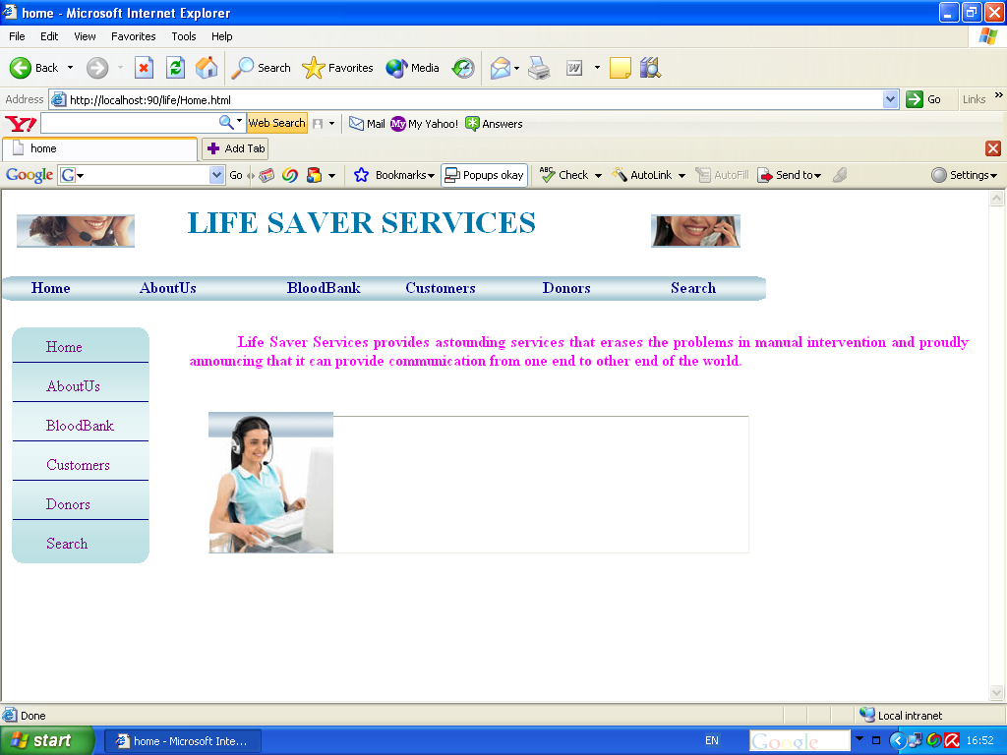

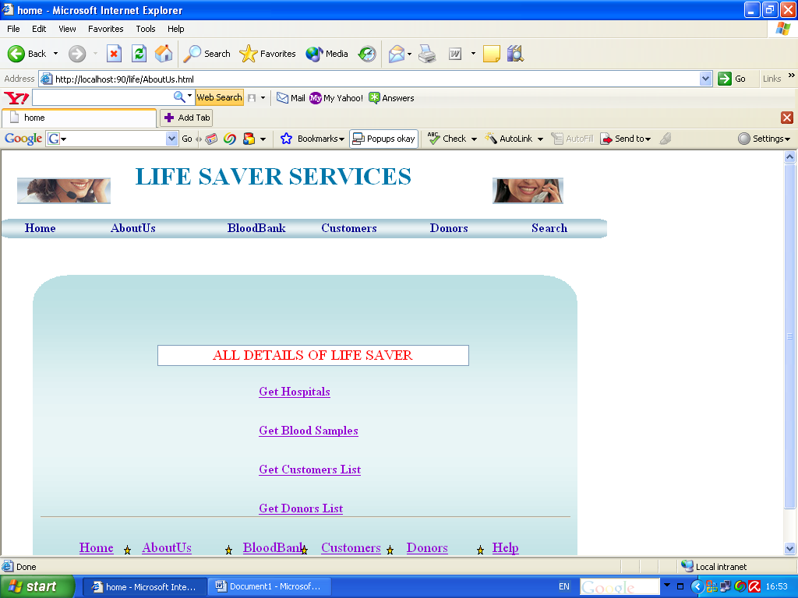

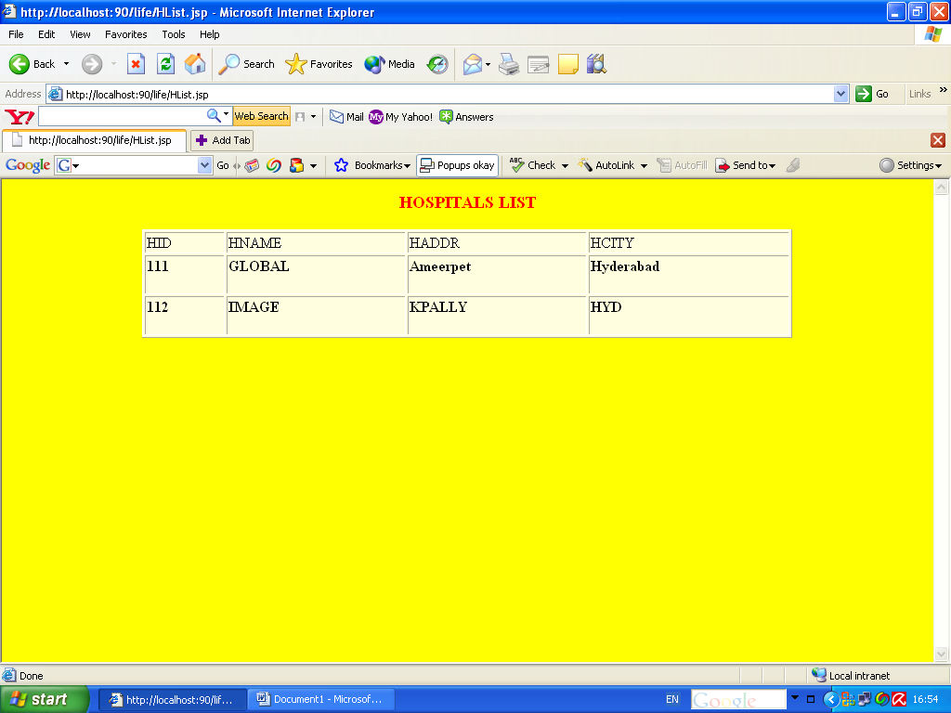

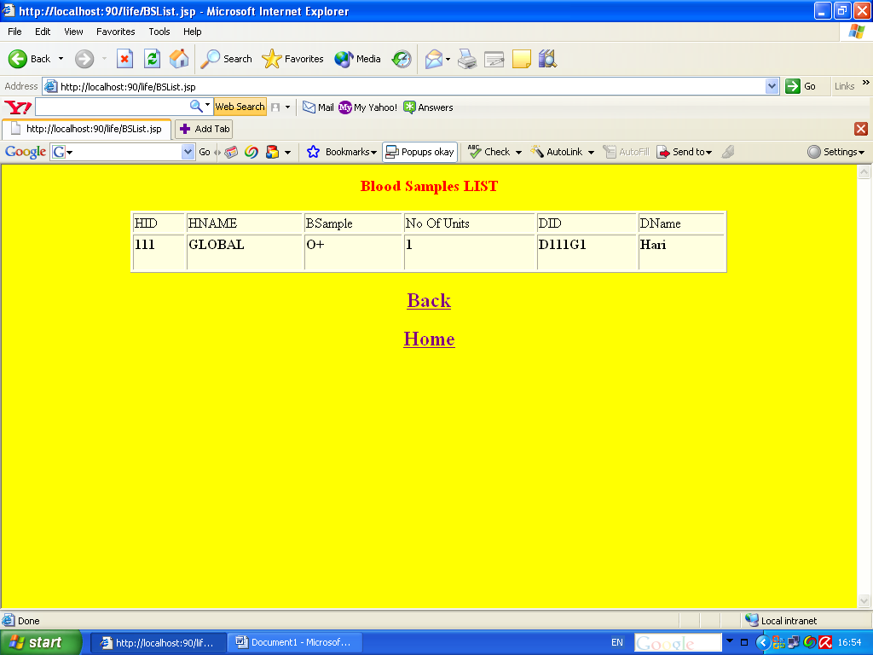

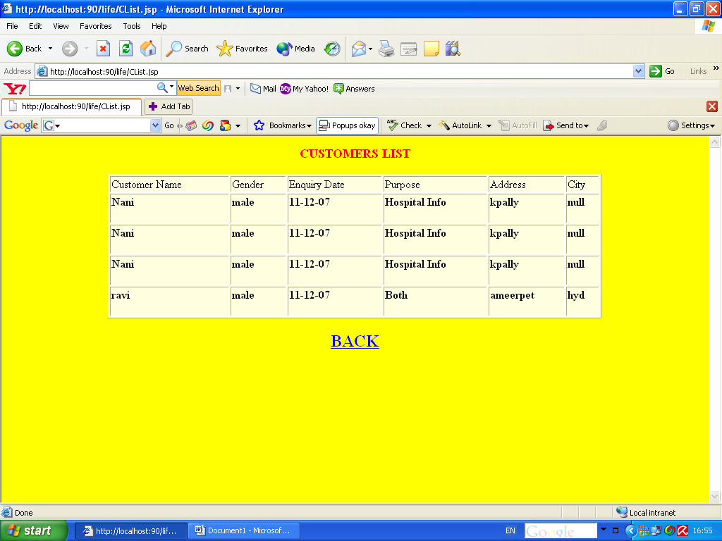

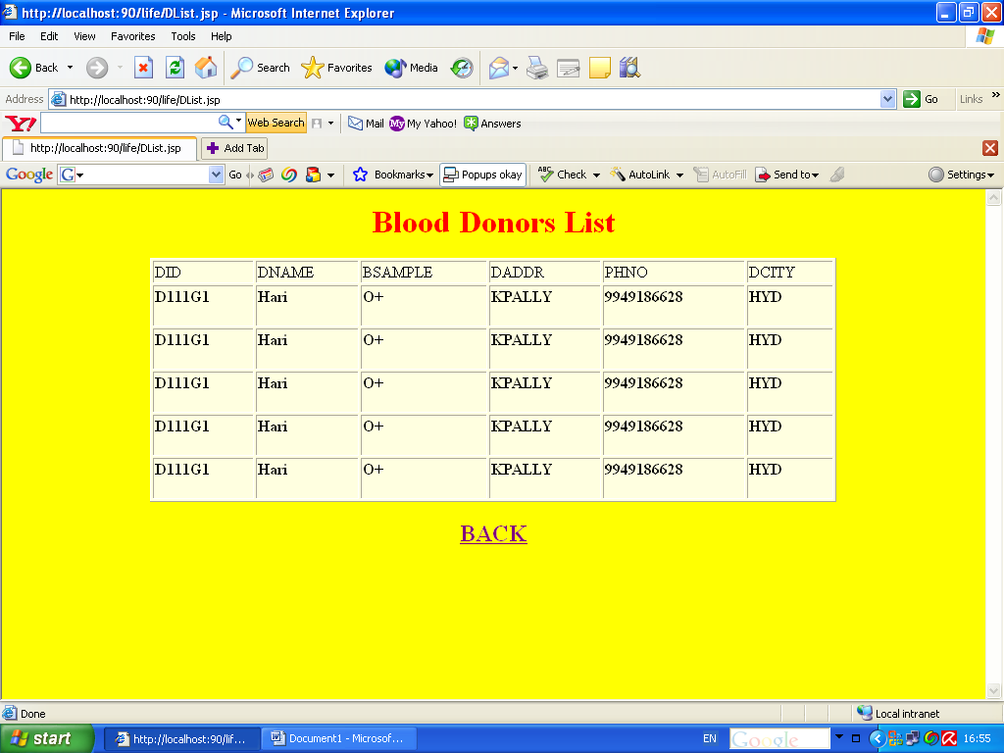

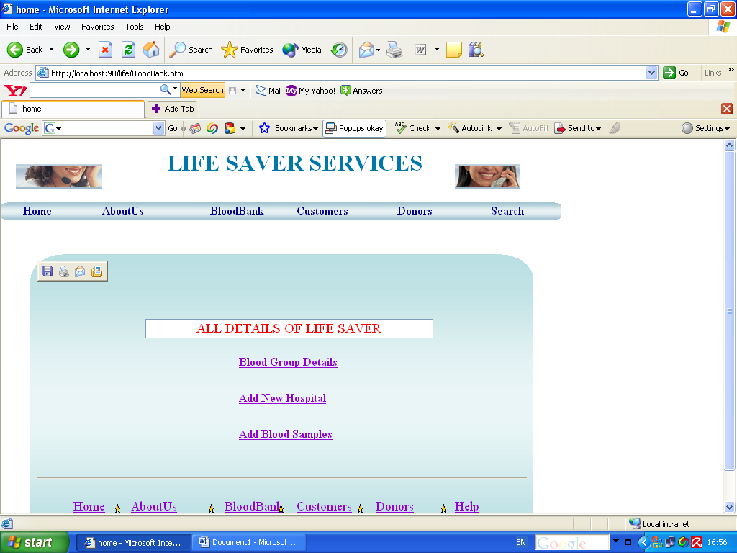

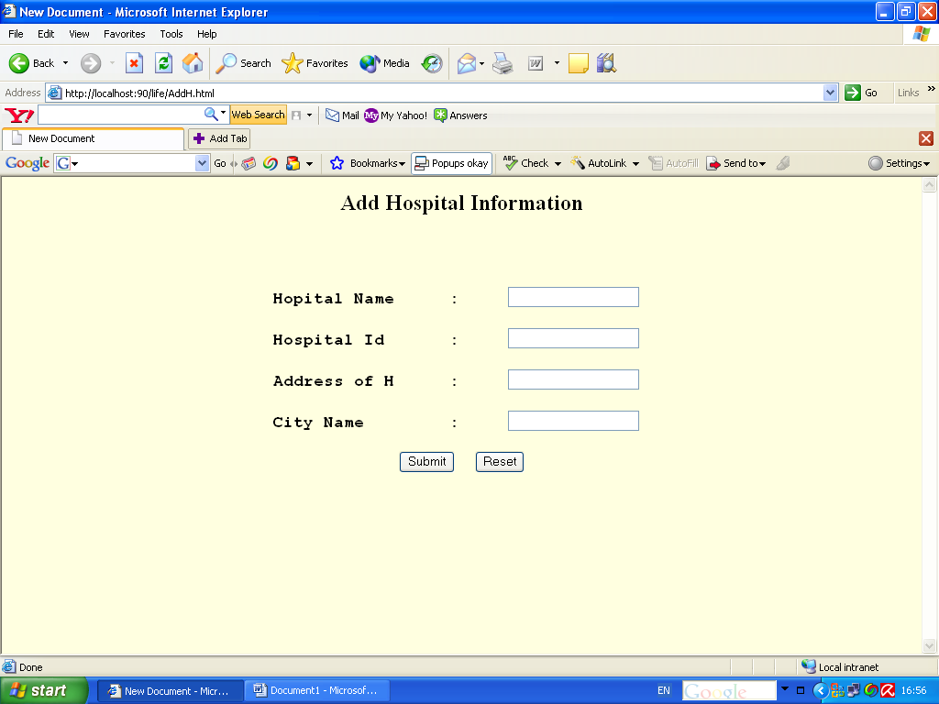

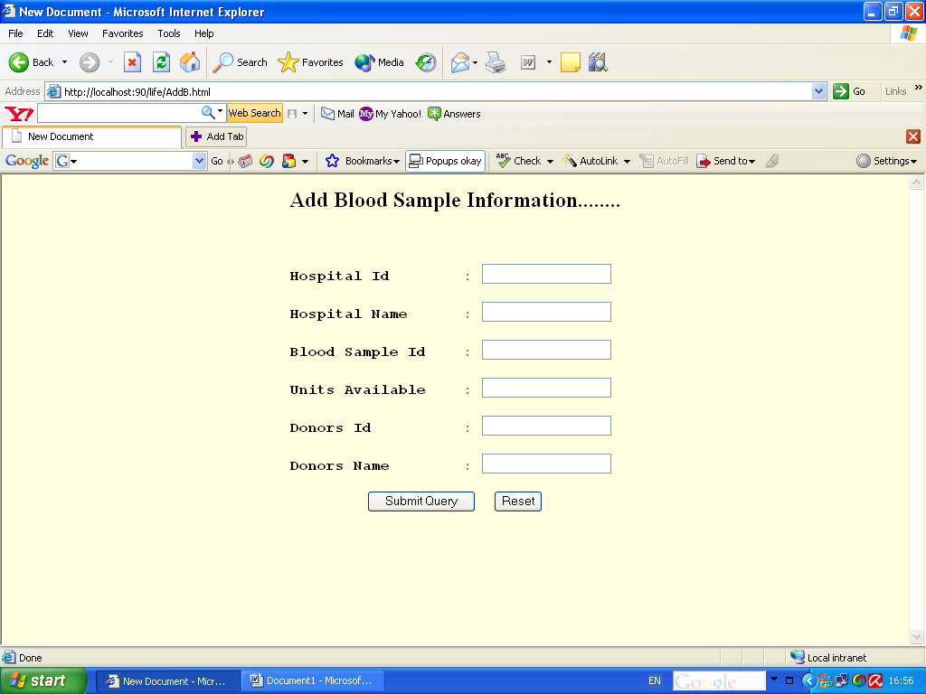

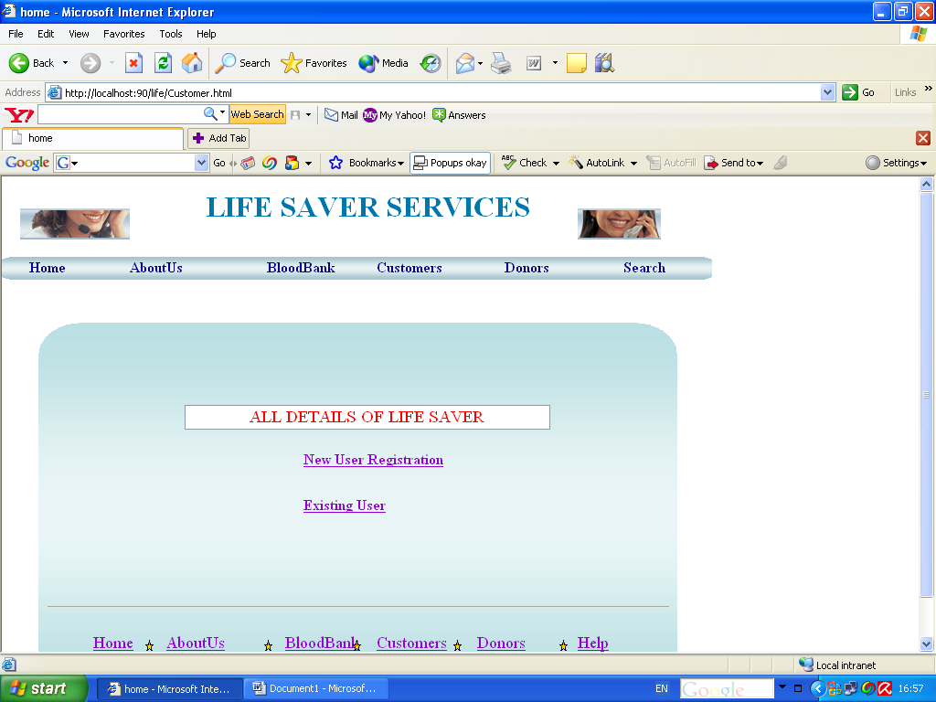

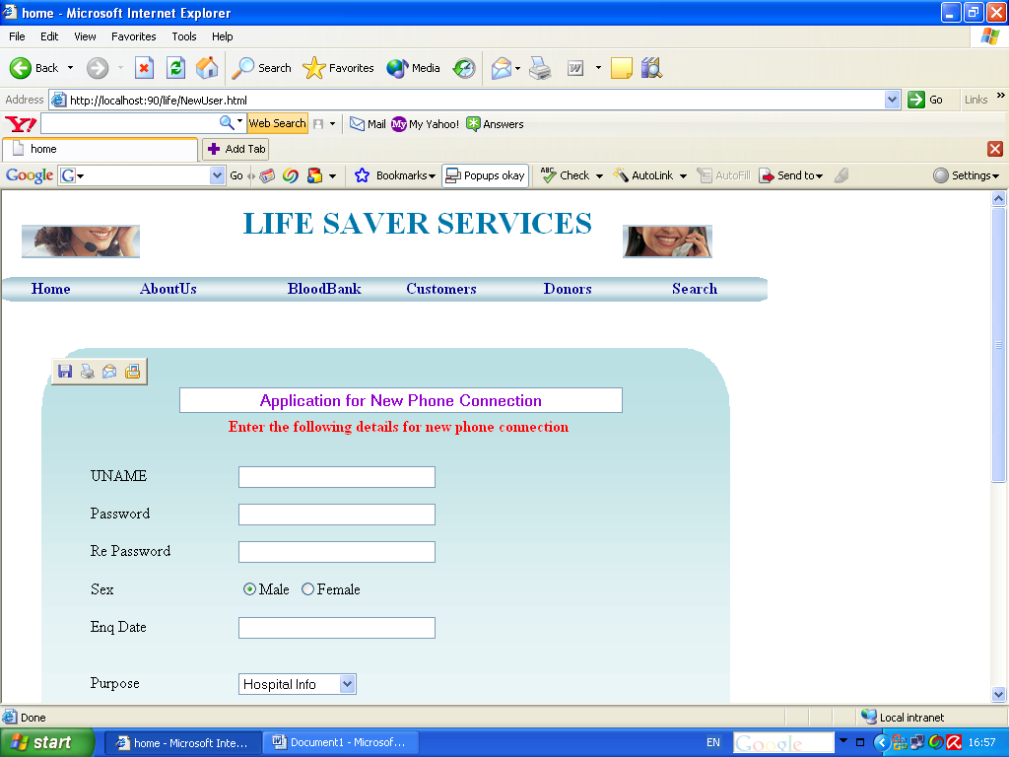

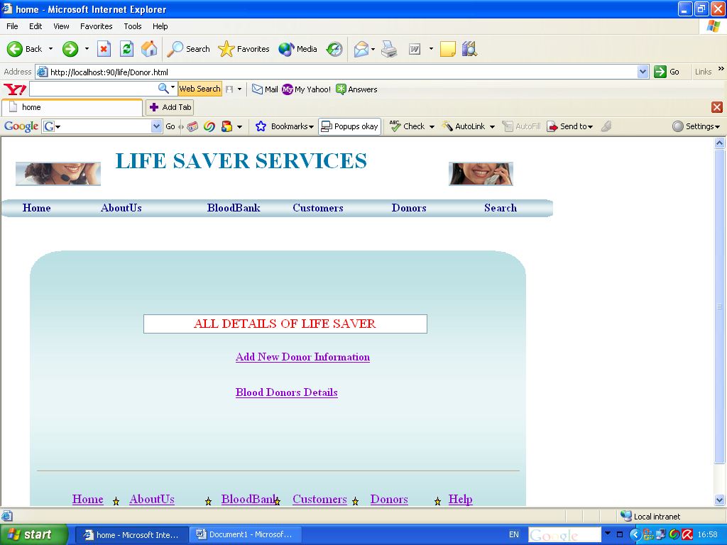

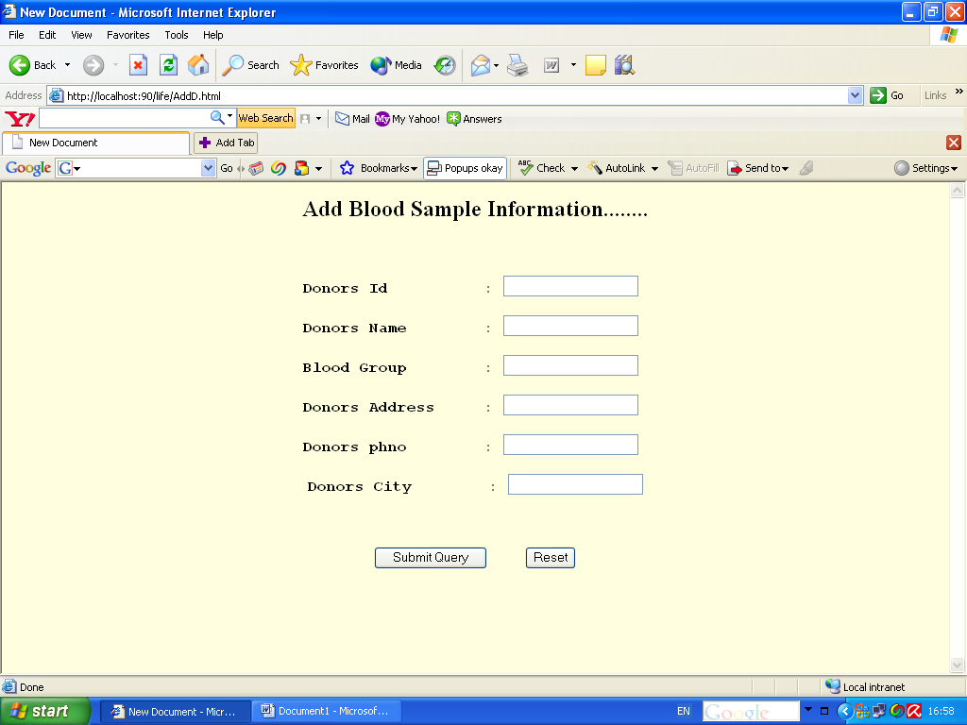

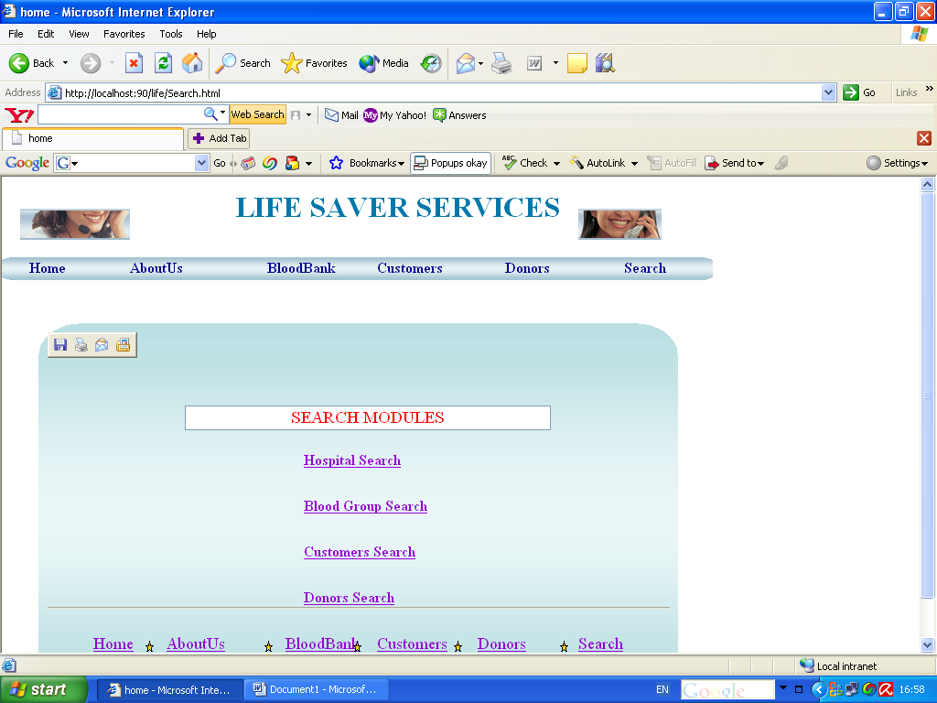

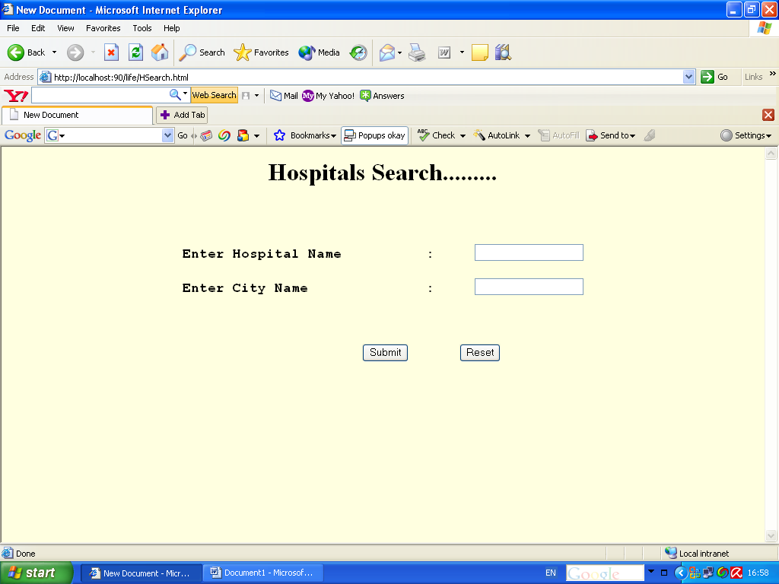

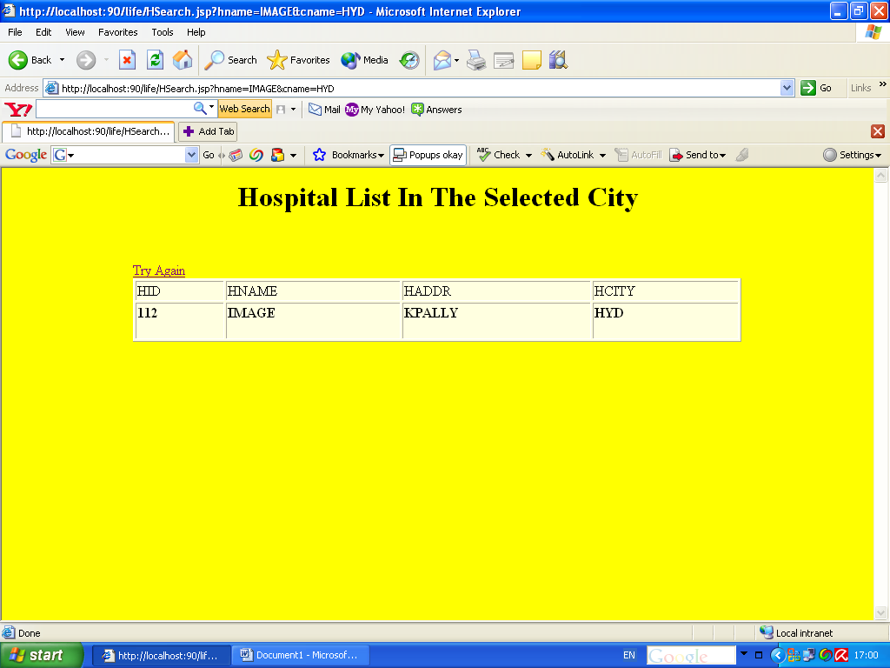

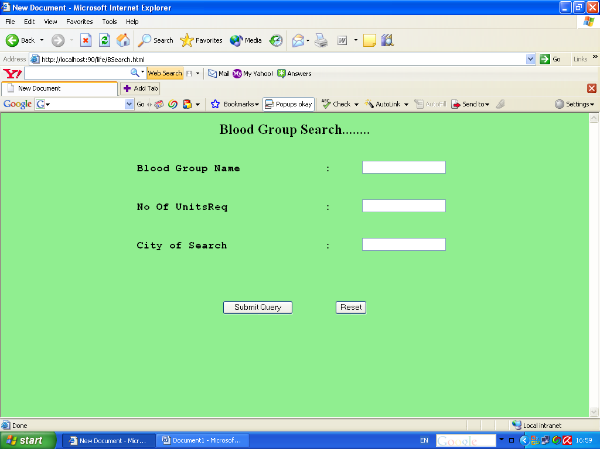

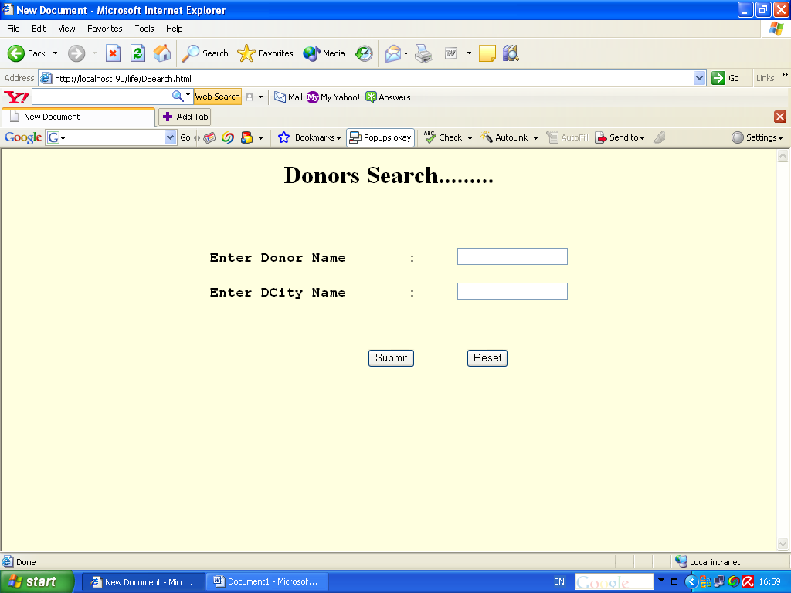

4. SYSTEM TESTING

Testing is the one step in the software engineering process that could be viewed as destructive rather than constructive. Testing requires that the developer discard preconceived notions of the "correctness" of the software just developed and overcome a conflict of interest that occurs when errors are uncovered.

If testing is conducted successfully, it uncovers errors in the software. As a secondary benefit, testing demonstrates that software functions appear to be working according to specification, that performance requirements appear to have been met. In addition, data collected as testing is conducted provide a good indication of software reliability and some indication of software quality as a whole.

Testing cannot show the absence of defects, it can only show that software defects are present.

4.1 OBJECTIVES

The objectives of testing are:

Testing is a process of executing a program with the intent of finding an error.

A good test case is one that has a high probability of finding an as yet undiscovered error.

A successful test is one that uncovers an as yet undiscovered error.

The software developed has been tested successfully using the following strategies and any errors that are encountered are corrected and again the part of the program or the procedure or function is put to testing until all the errors are removed.

4.2 TESTING SPECIFICATIONS AND DOCUMENTATION

Any engineering product can be tested in one of the two ways

- Knowing the specific function that a product has been designed to perform, tests can be performed that demonstrate each function is fully operational- Black Box Testing.

- Knowing the internal workings of product, tests can be conducted to ensure that internal operation of the product performs according to specification and all internal components have been adequately exercised - White Box Testing.

WHITE BOX TESTING

White Box Testing is a test case design method that uses the control structure of the procedure design to derive test cases. Using White Box Testing Method the following are evaluated:

- Guarantees that all the independent paths within a module have been exercised, at least once.

- Exercise all logical decisions on their true and false sides.

- Execute all loops at their boundaries and within their operational bounds.

- Exercise internal data structure to ensure their validity.

BASIS PATH TESTING

This enables the test designer to derive a logical complexity measure of a procedural design and use this measure as a guide for defining a basis set of execution paths.

Flow Graph Notation

This represents the control flow. Each structured construct has a flow graph symbol.

Cyclomatic Complexity

This is a software metric that provides a quantitative measure of the logical complexity of the program. The value here defines the number of independent paths in the basis set of a program and provides us with that all statements have been executed at least once.

Graph Matrices

This is a square matrix whose size is equal to the number of nodes and the flow graph. Then each row & column corresponds to an identified node and a matrix entry corresponds to connection between nodes.

Control Structure Testing

Condition Testing

This is a test case design method that exercises the logical conditions contained in a program module. This method focuses on testing each condition in the program.

This testing method has been used in the system for all the control structure statements encountered in the program. Providing sample data in such a way that all possibilities of the control structure are satisfied has carried out the test.

Data Flow Testing

This method selects test path of a program according to location of definitions and uses of variables in the program.

These testing strategies are useful for selecting test paths of a program containing nested-if and loop statements.

This system developed has been put to test under this data flow testing method. If statements and the loop statements were tested by providing suitable values at the respective locations.

The values are provided taking into consideration, satisfaction of the various outcomes of the IF and loop statements.

Loop Testing

This testing method focuses exclusively on the validity of loop constructs, simple loops, concatenated loops, nested loops and unstructured loops.

The loops in the system are tested using the loop testing method and are found not to possess any errors.

Black Box Testing

This enables the software engineer to derive sets of input conditions that will exercise all functional requirements for a program.

This attempts to find errors in the following categories:
Incorrect or missing functions
Interface Errors
Errors in data structures
External Database Access
Performance errors
Initialization and termination errors

This is carried out at the later stages of testing. Black Box Testing purposely disregards control structures; attention is focused on the information domain.

Equivalence Testing

This divides the input domain of the program into classes of data from which test cases can be derived. This is mainly used for testing
the input condition.

The input conditions used in the program are tested using this testing. The tests are carried out by not only giving correct inputs but also by giving wrong data what should be done under the circumstances when errors are encountered and this errors are encountered.

4.3 USER INTERFACE TESTING

Software testing is one element of a broader topic that is often referred to as in verification and validation. Verification refers to the set of activities that ensure that software correctly implements a specific function.

Validation refers to a different set of activities that ensure that the software that has been built is traceable to customer requirements.

Unit Testing:

Unit testing focuses verification effort on the smallest unit of software design-the module. Using this important control path is tested to uncover errors within the boundary of the module.

Integration Testing:

Integration Testing is a systematic technique for constructing the program structure while at the same time conducting tests to uncover errors associated with interfacing. The objective is to take unit testing modules and build a program structure that has been dictated by design.

Validation Testing:

The software validation testing is achieved through a series of black box tests that demonstrates conformity with requirements.

A test plan outlines the classes of test to be conducted and a test procedure defines specific test cases. The test cases that will be used to demonstrate conformity with requirements.
Alpha and Beta Testing:

The software developed has not been put to this test as the software is developed at the site of the customer and the customer has been asked to work with the software.

The beta test is conducted at one or more customer sites by the end user of the software. Unlike Alpha testing, the developer generally is not present. The beta tests if a live application of the software in an environment that cannot be controlled by the developer. The customer records the problems that are encountered during beta testing and reports this to the developer at regular intervals.

System Testing:

The system developed has been successfully tested under the system testing and all system elements are found to carry out their allocated tasks correctly. There are the various types of testing strategies implemented for the system developed.

4.4 DATA AND OUTPUT TESTING

Now we will see how the module has been tested and what result was achieved during the test. It is not possible to test all the modules with an example here. So it has been decided to show samples of test conducted and what result has been achieved when these tests were performed.

Text Fields

The text fields in the data entry screens are designed to accept only alphanumeric characters. Whenever a special character key is pressed.

IMPLEMENTATION AND MAINTENANCE

IMPLEMENTATION

Implementation includes all those activities that take place to convert from the old system to the new. The new system may be totally new, replacing an existing manual or it may be a major modification to an existing system. In either case, proper implementation may not guarantee improvement in the organization using the new system, but improper installation will prevent it.

The system developed has been tested at the site of the end-user. The system did not come under any errors during its testing and it satisfied all requirements of the end-user. So the system has been implemented using SQL server as its back-end at present.

The system by itself provides for maintenance of its database automatically. Once the financial year is over the past data is converted to a text format and stored in a separate directory that need to be created at he time of implementation.

5.1 HARDWARE REQUIREMENTS

The hardware requirements recommended for running this system and the minimum requirements for running the system are as follows:

333MHz processor (minimum) or 450 MHz (recommended)
32MB RAM (minimum) or 128MB RAM (recommended)
4 GB Hard Disk Drive or more
Printer (inkjet or dot matrix)
512KB cache
1.44” Floppy Disk Drive
Mouse and Keyboard

5.2 SOFTWARE REQUIREMENTS

This system can be run in a single machine or can be connected through network. So it is up to the installer to decide regarding the basic software as such. If the system is to be run then we need to make use of the Windows NT operating system or else Windows 95 or 98 will be sufficient. The detailed software requirements for running this software are as follows:

Windows NT 4.0 or above operating system

Windows 95 or 98 or above operating system

The VB software is not needed as the software is made up in the setup format of windows 98 and it is need to be installer while setup program is installed so as the application program run on the system.

5.3 INSTALLATION PROCEDURE

Once the system mentioned above are ready and the positions of the system are set. Then we need to install the software and configure the systems to the software. The processes that need to be carried out are given below:

Load SQL Server in the system that is to be used.
Run the setup. Exe in the software provided.
Answer the questions that are asked by the software
For e.g. the location of the software where it should be located.
Go to control panel and select ODBC data sources (32 bit) icon in the panel.
In the screen that follows click the ADD button.
Select the driver for SQL Server.

MAINTENANCE

Maintenance is far more than fixing mistakes. The maintenance can be defined using four activities that are undertaken after a program is released for use.

The first maintenance activity occurs because it is unreasonable to assume that software testing will uncover all latent errors in a large software system. The process that includes the diagnosis and correction and correction of one or more errors is called corrective maintenance.

The second activity that contributes to a definition of maintenance occurs because of the rapid change that encountered in every aspect of computing. Adaptive maintenance-as activity that modifies software to properly interface with a changing environment-is both necessary and commonplace.

The third activity that may be applied to as definition of maintenance occurs when a software package is successful. As the software is used new recommendations for new capabilities, modifications to existing functions, and general enchantments are received from the users, to satisfy this request perceptive maintenance is used.

The fourth maintenance activity occurs when software is changed to improve future maintainability or reliability, or to provide a better basis for future enhancements. This is often called preventive maintenance, which is characterized by reverse engineering and Re- engineering techniques. When these tasks are applied to existing program, it is called maintenances.

MAINTENANCE PROCEDURE

The system has been tested in the location of the developer. But it is not possible to find all errors here. It may be that after thorough testing, the user will find errors. In such a case the user when reports the errors it is possible to correct these errors as the coding has been documented and it is possible to find out the location where the error is occurring and the reason for the error can be analyzed and corrected. Thus we can say the system supports for Corrective maintenance.

As this software can be run with the requirements given above and it does not involve any particular hardware as such can be run with rapid developments that is being encountered in the counterpart in the computer industry.

Relating to the requirements of the software as it is uses the GUI principles it can be run any version of windows operating system or the Windows NT system.

Relating to the Databases used it is just necessary that we need them to only store data and all operations are carried out using the application. A new version of the database system will always support the older version activities.

This shows that the system developed is adaptive to the changes in hardware or software. So the system supports adaptive maintenance.

It may be that end-user may want some modifications to be made to the existing functions and enhance the capabilities of the existing system. It is possible to do these activities in the existing system and as the coding has been properly documented it is easy to make these changes to the existing function. This shows that the system supports for perfect maintenance.

Finally relating to the preventive maintenance, the software is to be changed to improve further maintainability and reliability of the system. As the documentation of the system provides for all the details that are taken care of while developing the system. Using these we can carry out the above activities. This shows that the system supports for carrying out the maintenance activities on the software.

8. CONCLUSION

This package has been able to successfully incorporate all the requirements as specified by the client. Appropriate care has been taken during database design maintain database integrity and to avoid redundancy of data. Validation is done instantaneously to avoid data redundancy of data. The client is provided a friendly interface by hiding all technical complexities. The package was done is such a way that any further modification’s needed can be easily done. The user is provided a friendly interface by hiding all technical complexities.

The addition, deletion and modification of student’s details are very user friendly, simple and easy. It is aimed at overcoming the shortcoming of manually operated system. The quality factors like: correctness, reliability, efficiency, usability, testability; maintainability, portability, accuracy, errors, tolerance, expandability and communicatively are all successfully met with. Validation certification was done to see that the package conforms to standards

9. References

REFERANCE BOOKS:

1. SOFTWARE ENGINEERING

- ROGER.S.PRESMAN

2.SYSTEM ANALYSIS AND DESIGN

- ELIAS.M.AWAD

3.DATABASE MANAGEMENT SYSTEM

- HENRY.F.KORTH

4.MASTERING VISUALBASIC 6.0

- EVANGELOS PETROUTSOS

5.PROGRAMMERS GUIDE

- MANUAL, MICROSOFT PRESS

